User

**Student ID: IT21806636  
 Batch : IT.Y2.S2.01.01 Weekend  
 Absent Assignment: Lab 1 n Lab 2**

Pet care mobile app

Report Document

**Pet Care Mobile App Report Document**

**Introduction**

Nowadays, smartphones have fallen into everyone's hands. People constantly rely on

efficient applications for mobile devices as a result to make their professions easier.

The goal of our team has been toward creating a mobile application that will help everyone who

owns pets receive the best possible animal care system.

This app is used by pet owners, transporters, veterinary technicians, and pharmacists. This app

allows pet owners to store healthcare records and pet details, establish an

appointment at their preferred veterinarians clinic, follow the status of their appointment, upload

prescription facts, engage with pharmacists, and transport pets in Complex and challenging situations

by getting in connection with a pet transporter.

For pets who are unable to see a medical professional because of the pandemic, this app will be

extremely valuable. By sacrificing information on animal health care, medical information,

appointment scheduling, a pharmacy, and transportation services, this application is intended to

assist users go about their daily lives more effortlessly.

**Contribution**

|  |  |
| --- | --- |
| **Pet Owner:**   * Register (Insert) as pet owner, Add pet details, Update pet details, Delete pet details * Appointments * Make an appointment * Cancel appointment * Check appointment status | **Veterinarian:**   * Register (Insert) as veterinarian, Update vet profile, Delete vet profile * Manage appointments * View appointment details * Accept or delete pending appointments * View and delete confirmed appointments   **Pet Owner:**   * Search pet clinic, View clinic details |
| **Pharmacists:**   * Register (Insert) the pharmacy, Update pharmacy details, Delete pharmacy details * Manage prescriptions * View and process the order * Calculate the bill   **Pet Owner:**   * Upload the prescription and accept make the order | **Pet Transporter:**   * Register (Insert) as a pet transport driver, Update profile details, Delete profile * Manage trips * View, accept or cancel requested trips * Calculate the destination hire   **Pet Owner:**   * Choose pet transport method * View and connect with a driver |

**Manage pet records, Handle appointments, View pet clinics**

**and Make an appointment**

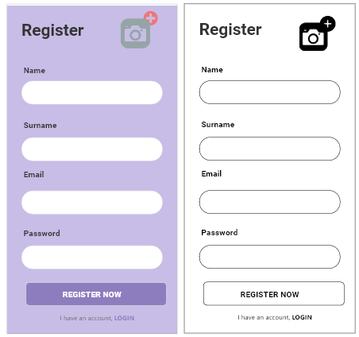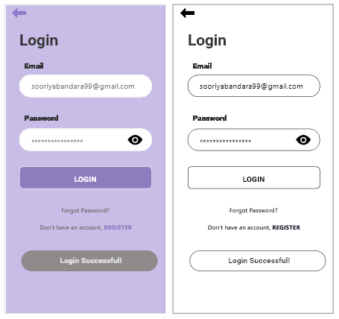

**Pet Owner Login**

Pet owner can login to the system by providing their email and password. If the pet owner hasn’t registered to the system, yet they can be registered by clicking the provided link in the below.

**Register New Pet Owner**

Pet owner can register to the system by entering valid credentials. Then the pet owner will be able to login to the home page. If the doctor already has an account, he or she can go to the login page by clicking the provided link in the bottom.

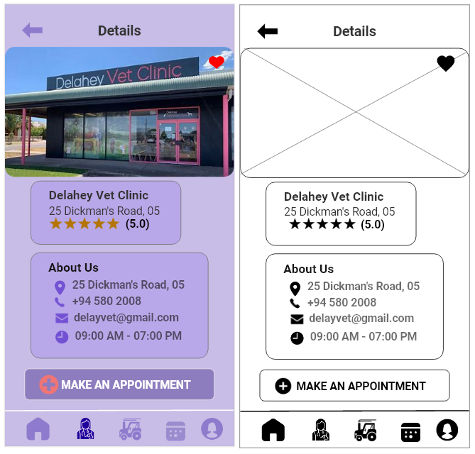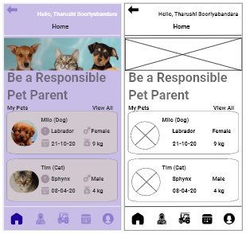

**View Veterinarian clinic details**

Once the pet owner chooses one veterinarian clinic which he or she preferred, he can be able to see information about that clinic. Then if the pet owner satisfied about the clinic, he can send a request to veterinarian clinic, click on the make an appointment button.

**Pet Owner Home Page**

This is the home page of the pet. This page shows all the included pets of the pet owner. Pet owner can navigate to vet clinic page, pet transport page, appointment page and pet profile page.

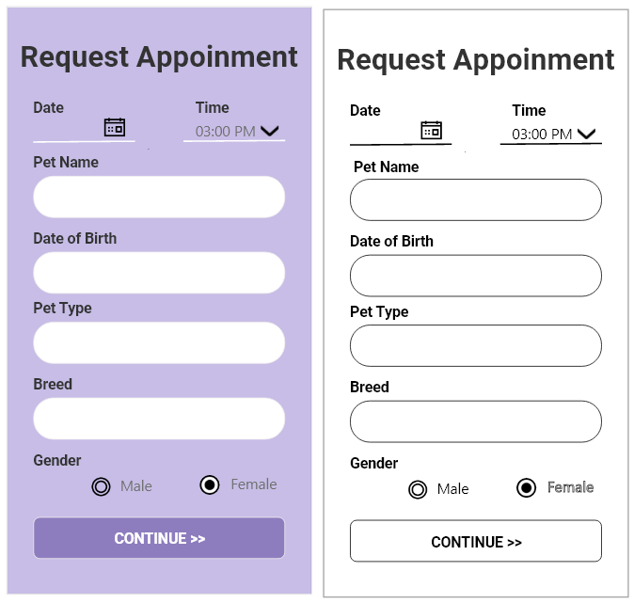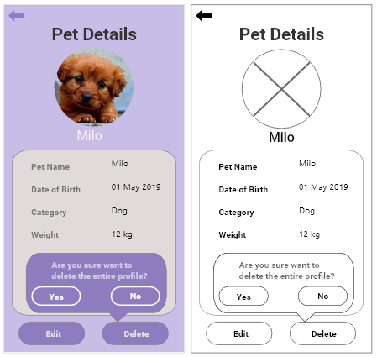

**Make an appointment**

Pet owner can request an appointment to veterinarian by completing this request appointment form. If the pet owner clicks on the submit button the appointment request sent to the veterinarian clinic which the pet owner choose.

**View Pet Details**

When the pet owner proving details of their pet and click on the save button, he or she can view this pet details page. Once the pet owner clicks on the delete button, then show a toast message “Are you sure want to delete this entire profile?” when click on the (yes) button, delete all details of their pet.

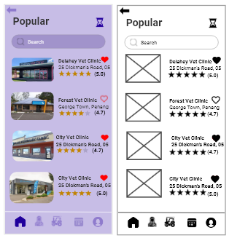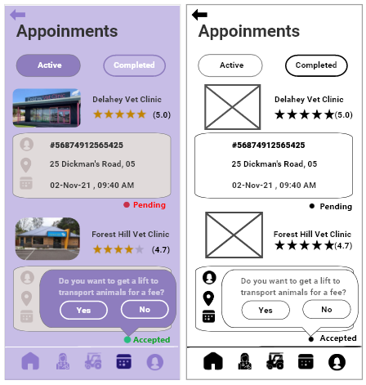

**View Appointment Status**

Once the veterinarian accepts or decline our appointment request, the pet owner can be able to see the appointment status through this appointment page. Though the veterinarian accepts our request, through this page shows a user-friendly message. When the pet owner clicks on the yes button this Appointments page navigate to Pet Transport page.

**View the list of clinic details**

The pet owner can be able to see

the list of clinic details and he or she can search and find veterinary clinics through this page by providing the nearest location, or preferred veterinary clinic name.



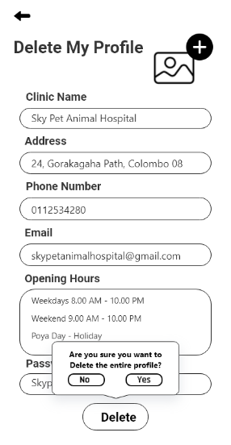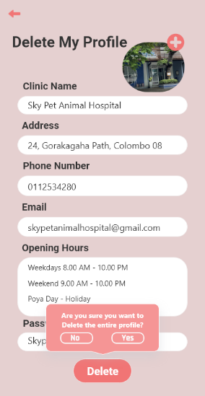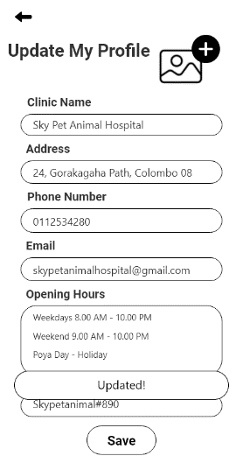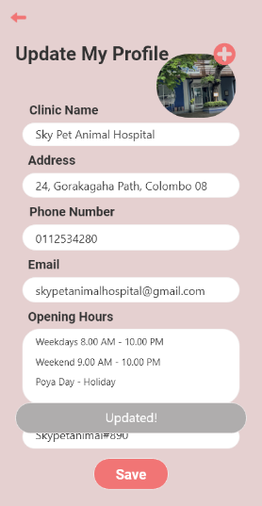



**Manage Pet Transport Drivers**

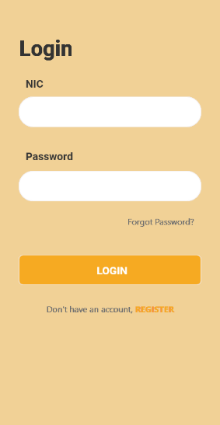 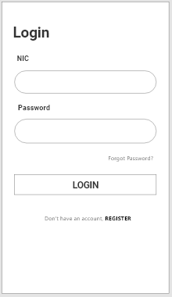 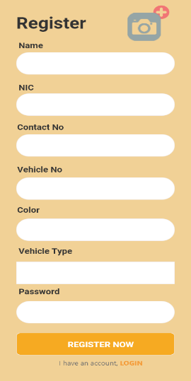 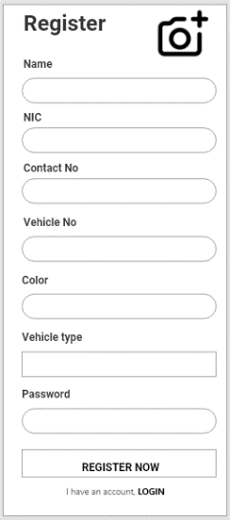

**Driver Login Register New Driver**

Driver can login to the system by Driver can register to the system by

providing their NIC and password. providing valid details in the given form.

If the driver hasn’t registered to Then the driver will be able to login

The system, yet they can register by clicking to the system.





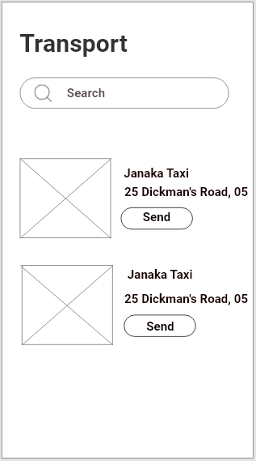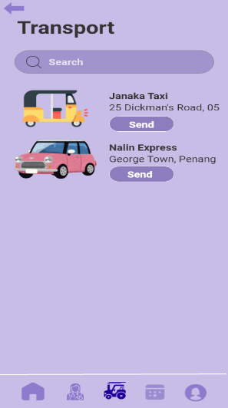

**View transport methods**

This screen the pet owner can choose

any available driver for him/his. When

choose driver and click send button

driver will get pet owner location and

clinic location (when click send button These details

send to the driver)

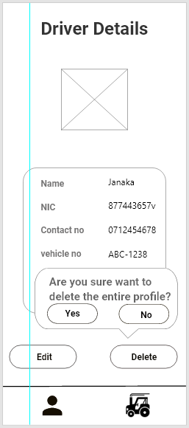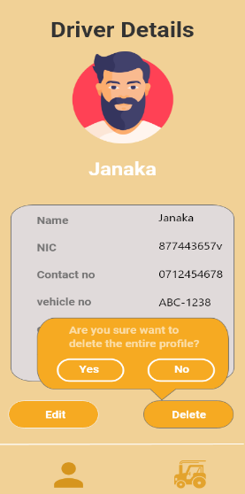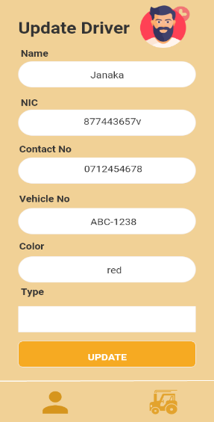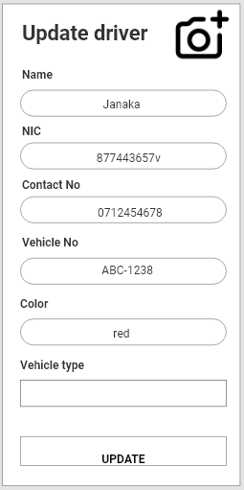

**Update Driver Profile**

**Delete Driver Profile**

Driver able to update his or her profile Driver can delete his or her profile

details through this page. Once the driver through this page. Once the Driver

edit details and click on the save button, this clicks on the delete button, this page will

page will display the successful update message. His profile deleted from database and

show toast message

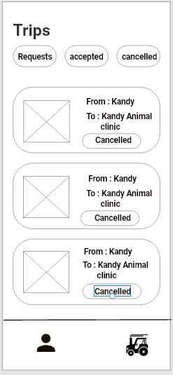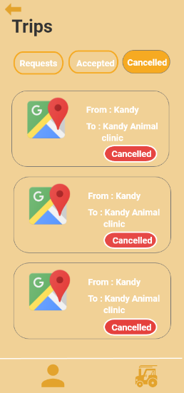

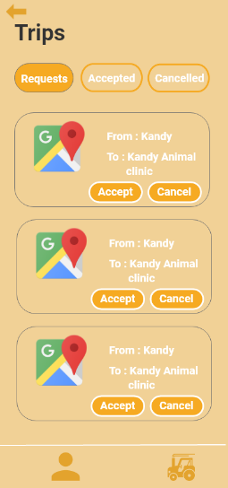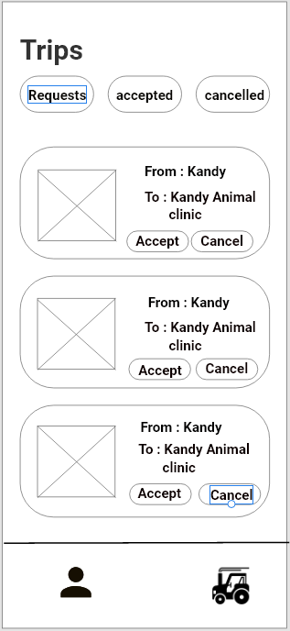

**Manage Requests View Cancelled Requests**

Driver can manage all available requests In this screen driver can view all

From pet owners.in this screens he can accept or cancel cancelled requests by him.

Any request

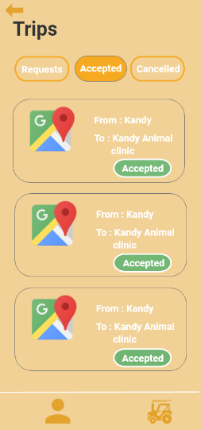

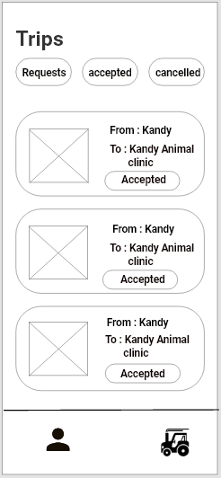

**View Accepted Requests**

Driver can view all available

requests

For his. Also, he can accept or

cancel any

Request from this page. when

click accept

Buttons calculate cost for

distance and send it to the pet owner

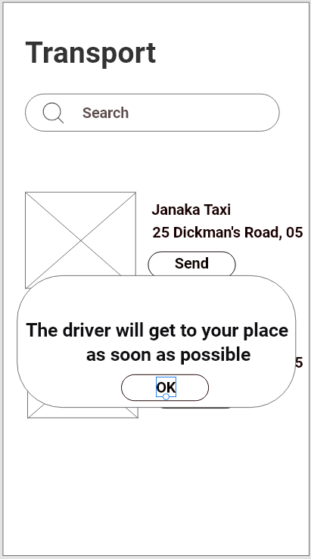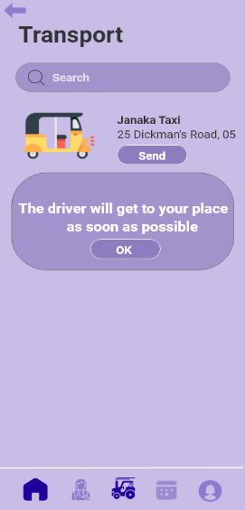

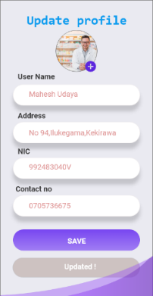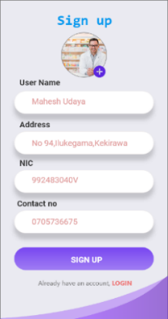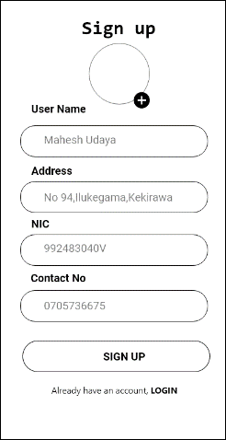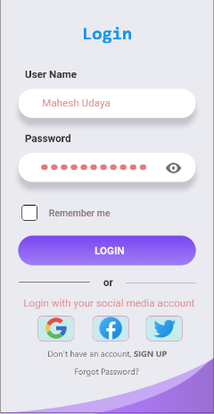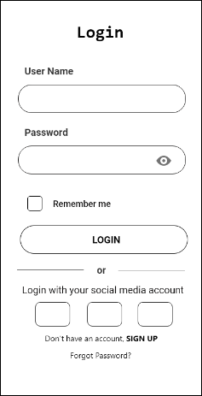 **Manage Pharmacist, Manage Prescriptions, Calculate Bill**

Pharmacist Update profile

Pharmacist can update their profile

by providing the details. After

click save toast message is

appearing and the details

are saved.

Pharmacist Sign up

Pharmacist can register to the system by providing the requested details. If the pharmacist already has an account, he/she can go to the login page by clicking the provided link below.

Pharmacist Login

Pharmacist can login to the app by providing their username and password. Also, they can use their social media accounts for this. If the pharmacist hasn’t registered to the system yet they can sign up by clicking the provided link at the bottom.

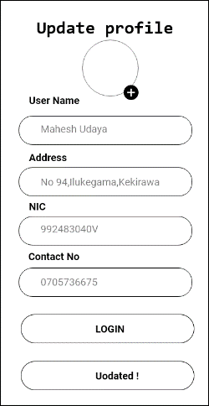

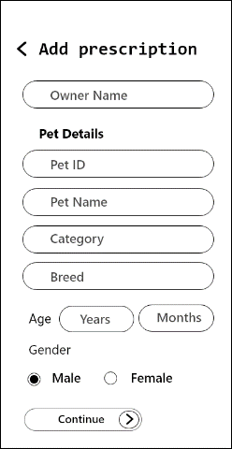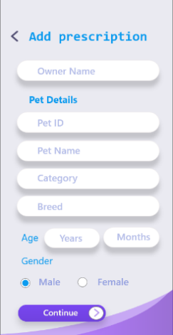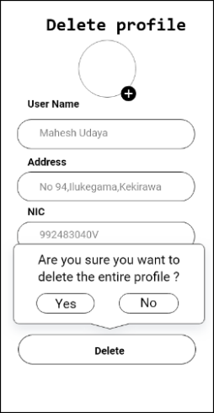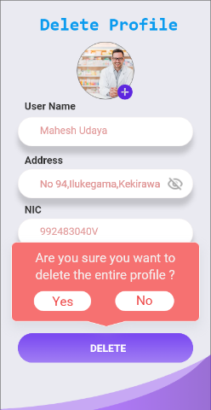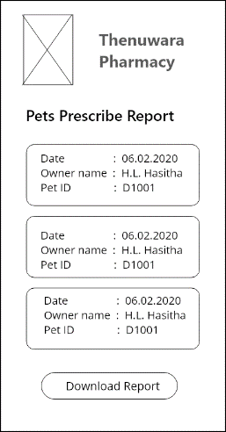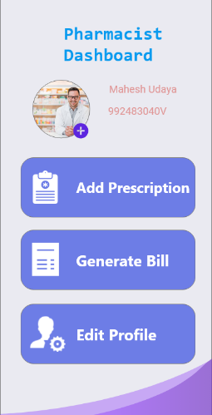

Pharmacist Delete profile

Pharmacist can delete their profile by clicking the delete button. after clicking delete button confirm message is appearing. If the pharmacist click yes account is deleted. If click no account will not deleted.

Pharmacist dashboard

Pharmacist can manage the work from the dashboard. If pharmacist want to add new prescription, he or she can add them. And also, he/she can generate bills by clicking generate bill button. She/he can edit their profile by clicking edit profile button.

Veterinarian Add prescription

After examining the pet, the

veterinarian can add pet details

to prescribe medicine. After

clicking

next the screen will navigate to

prescribe medicine screen to

add medicines.

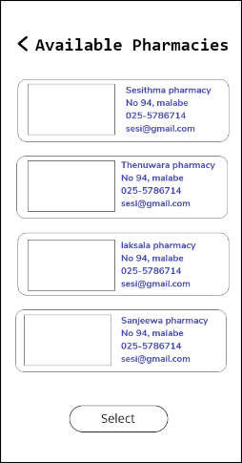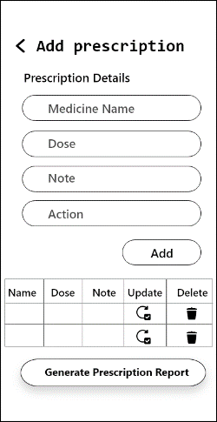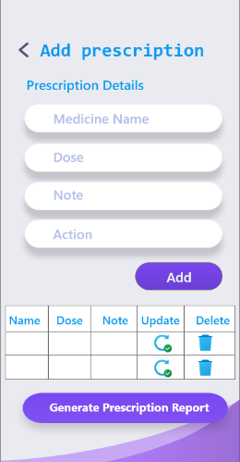

**Pet owner - Select Pharmacy**

After receiving prescription report sent by veterinarian. pet owner can decide from which pharmacy get medicine. He/she can search available pharmacies and select their pharmacy.

**Veterinarian add medicine**

After entering the pet details veterinarian can decide the medicines and he/she can enter those medicines into the prescription details. If he/she wants to update or delete any record that can be done by selecting the relevant update and delete buttons on the table. Finally, he can click generate report button to generate report.

**Prescription report**

After clicking generate report the generated report will previewed, and veterinarian can decide whether report download or share to the pet owner. Entering the pet owner email address to send that report to pet owner’s email.

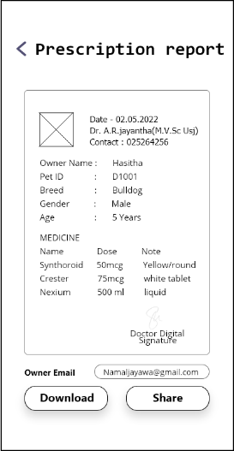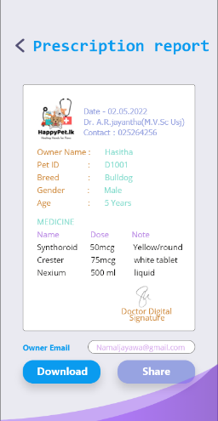

––

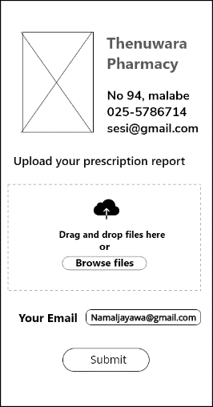

**Pet Owner Upload prescription report**

Pet owner can upload the prescription report by drag and drop or browsing the files. Providing the pet owners email and submitting the report will send that report to relevant pharmacy email.

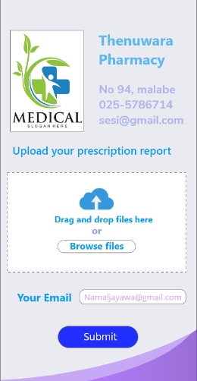

**Add prescription**

**Pharmacist Bill calculation**

After receiving prescription report s

end by the pet owner pharmacist can

enter medicines and calculate total.

If he wants to update or delete

his/her entered record that can be

done by clicking update and

delete buttons.

**Received prescribe reports**

Pharmacist can view the received prescription report sent by pet owners. And selecting the relevant report and clicking download button will download the prescription report.

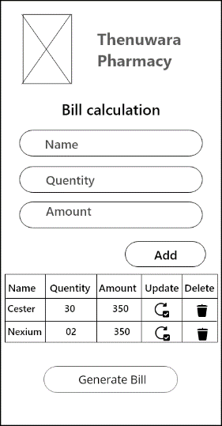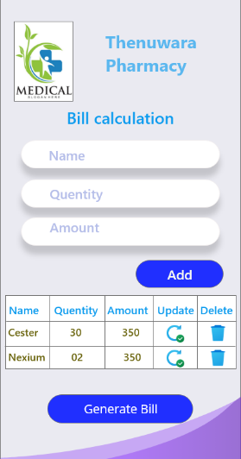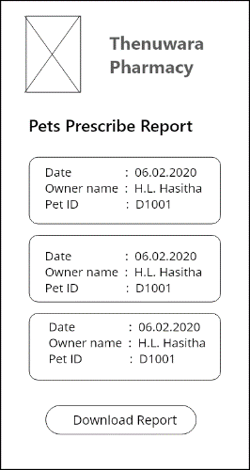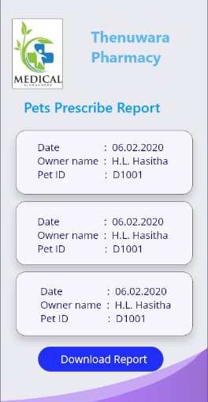

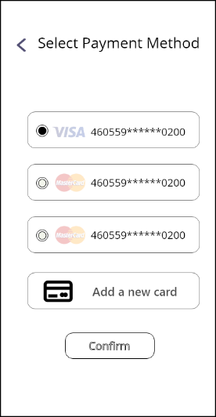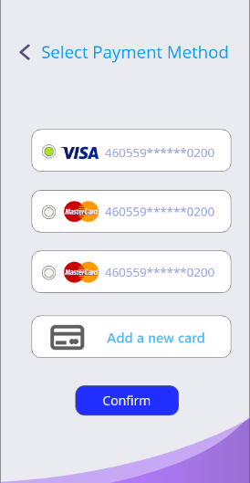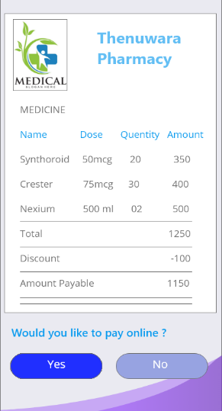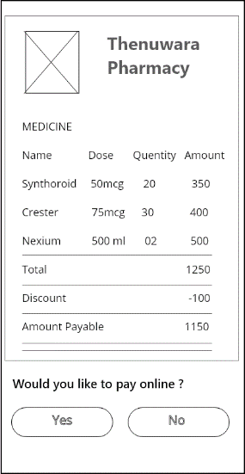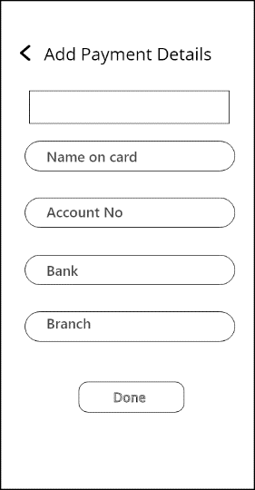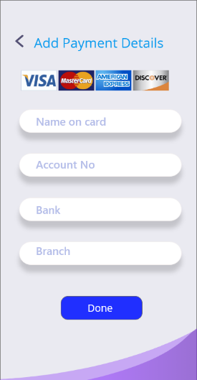

Select payment method

**Select payment method**

Pet owner can select the card type and click confirm button. After clicking confirm, payment is completed, and pet owner can get the medicines. If he/she wants to add new card they can add new card by add new card button.

**Add payment details**

Pet owner can add payment details to add his/her payment method. After adding card details, those details are added to payment method screen.

**Pet owner - bill payment message**

After sending the prescription bill to pet owner, he/she can decide whether that bill pay online or not. If he/she clicks yes, the screen navigate to select payment method screen. If click no, the screen will navigate to home screen.

|  |  |
| --- | --- |
|  |  |
|  |  |

**Discussion**

An app for pet care enables convenience and assist to pet owners, veterinarians,

pharmacists, and pet transporters by streamlining different parts of pet care. In the

modern world, where smartphones are widely used and people are looking for

cost-effective ways to manage the well-being and wellness of their pets, this kind

of application is especially pertinent. This is an explanation of the main features of a

pet care app.

User-Friendly Interface:

A well-thought-out pet care app ought to have an easy-to-use interface that can be

used by pet owners of different technological skill levels. It should be simple for users to

navigate between the various features and functionalities thanks to a clear layout.

Management of Pet Information:

Pet owners can store vital information about their animals with the app, such as

vaccination records, dietary preferences, and medical records. Better communication

with veterinarians and other pet care professionals is made possible by this central

repository, which confirms that important information stays easily accessible.

Scheduling and Monitoring Appointments:

Pet owners can use the app to check appointing statuses, schedule appointments with

their preferred veterinarians, and receive reminders. This feature guarantees prompt

veterinary care and facilitates efficient scheduling, arranging, and governance

of a pet's health-related regimen.

Prescription Management:

Putting and managing prescription data is a common feature of pet care applications.

This offers a practical way to remember prescribed treatments and dosages, which can

be especially helpful for pet owners who have to give medications to their animals.

Relationship with Experts:

Professionals in the pet care industry can communicate with pet owners more easily

thanks to the app. In order to ensure smooth and secure transportation under

different conditions, users can communicate with pet transporters and

pharmacists about prescription regimens.

Assistance in an emergency:

The app can give users instant access to crucial information in an emergency, like the

locations of the closest vet offices or emergency pet care services. This function can

be extremely helpful when urgent action is needed.

Pandemic Considerations: A pet care app becomes even more pertinent in light of the

challenges presented by the pandemic. For pet owners who might be reluctant to visit

actual veterinary clinics, it acts as a lifeline by enabling remote access to crucial

services and consultations.

Wholesome Integration of Lifestyle:

With features like pet transportation services, the app can fit into pet owners' daily

routines even beyond their urgent medical needs. This all-encompassing strategy

guarantees that the app turns into an essential component of the regular pet

care regimen.

To put it briefly, a well-designed pet care app facilitates effective communication,

organization, and access to necessary services while catering to the various needs of

pet owners and industry professionals. These kinds of apps are essential to

improving pets' general health and making their owners' jobs easier as long as

technology keeps developing.

**Conclusion**

In conclusion, a pet care app proves to be a useful and adaptable resource, meeting the

changing demands of pet owners in the digital era. The widespread use of smartphones

has made it possible for applications to be developed that blend in seamlessly with the

daily routines of those who are in charge of their pets' welfare. With features like

prescription tracking, appointment scheduling, centralized pet information

management, and links to veterinarians, these apps simplify, organize, and make the

complicated world of pet care more approachable.

Additionally, in the face of unanticipated difficulties such as the current pandemic, a

pet care app is a lifesaver, offering vital services from a distance and guaranteeing that

pets receive the care they require even in situations where making in-person trips to

veterinary clinics may be difficult. These applications are so comprehensive that they

cover things like emergency aid and pet transportation in addition to the immediate

healthcare needs.

Pet care apps are set to become more and more important in promoting the general

health, happiness, and well-being of animal companions as technology develops and

the relationship between people and their pets grows. These apps use the power of

mobile technology to make pet care more connected, knowledgeable, and effective,

ultimately improving the lives of devoted pet owners and their beloved companions.